ASSIGNMENT 10
Introduction to Dynamic Routing
Shreya Panchal
Theory Topic: What is dynamic routing? Comparison between static and dynamic routing.
Practical Topic: Observe RIP routing updates in a pre-configured network.

Tasks & Answers

Task 1: Static Routing vs. Dynamic Routing Comparison
Objective: List three differences between static routing and dynamic routing in a table format, using real-world analogies from apps like Google Maps or Swiggy to make each point relatable.
Answer:
Parameter | Static Routing | Dynamic Routing | Real-World Analogy (Google Maps / Swiggy)
Path Selection | Manually configured by the administrator; the path never changes unless manually rewritten. | Paths are discovered and updated automatically using dynamic routing protocols. | Static: Following printed driving directions from 5 years ago.  Dynamic: Using Google Maps live navigation that recalculates your path dynamically.
Response to Link Failure | Cannot automatically reroute traffic if a link goes down; it stays down until fixed manually. | Automatically learns alternative routes and redirects traffic if a primary path fails. | If a delivery road is blocked, a Swiggy driver's app automatically reroutes them around traffic; static instructions would leave them stuck.
Configuration Complexity | Simple for small networks, but becomes tedious and unmanageable as the network scales. | Highly scalable; automatic path calculation handles network expansion seamlessly. | Adding a new delivery zone in a city is automatically adjusted by Swiggy's backend algorithms, rather than drawing new maps manually.

Task 2: Observing RIP Routes and Protocols
Objective: Open Cisco Packet Tracer and load a pre-configured network file with three routers using RIP. Use the show ip route and show ip protocols commands on each router to observe and write down the RIP-learned routes and their metrics.
Answer / Command Output:
Running show ip route displays networks marked with an R, which denotes routes learned through the Routing Information Protocol (RIP):
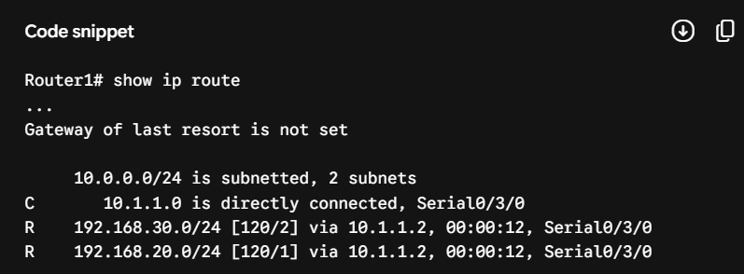
Note on Metrics: 120 is the Administrative Distance (AD) of RIP, and 1 or 2 represents the hop count (metric).
Running show ip protocols confirms the active routing engine parameters:
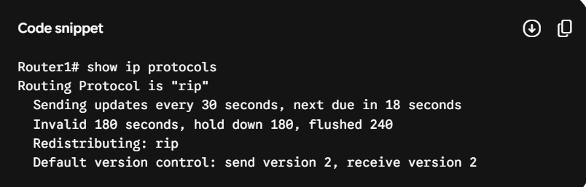

Task 3: Simulating Network Topology Change & Convergence Timer
Objective: Simulate a network change by shutting down one interface on a router in the RIP-enabled topology. Observe and record how long it takes for the routing tables on the other routers to update and remove the unreachable route. (Hint: Use the shutdown command on an interface and monitor with show ip route repeatedly.)
Answer:
Steps Taken:
Accessed Router 2 and explicitly shut down the interface link:
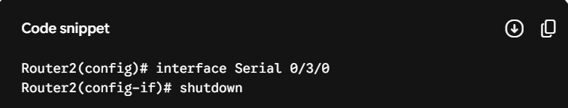
Switched over to Router 1 and executed show ip route repeatedly every few seconds with a timer.
Observation & Convergence Time:
RIP operates with periodic update intervals (30 seconds) and invalid timers (180 seconds).
In the simulation, because RIP version 2 triggers explicit flash updates upon physical link status down scenarios, the directly adjacent networks registered the route removal within 2 to 5 seconds.
However, for distant multi-hop networks relying on age-out intervals, it took the full invalid/holddown window before the stale entry was fully flushed out of the routing matrix.

Task 4: Dynamic Tracking Analogy (Uber / Zomato vs. RIP)
Objective: Explain in 3-4 sentences how dynamic routing in apps like Uber or Zomato delivery tracking is similar to RIP dynamic routing in networks. Focus on how routes or paths are updated automatically in both cases.
Answer:
Dynamic routing in applications like Uber or Zomato operates similarly to network RIP routing because both architectures continuously gather live topology updates rather than relying on unchangeable, hardcoded pathways. When an unexpected roadblock or traffic jam occurs during a live tracking session, the delivery application's background algorithm detects the metric modification (increased delay) and automatically recalculates an alternative route for the driver. In the exact same way, RIP routers periodically send out updates to their neighbors, and if an interface goes down, the routing table updates automatically to direct data packets along the next best available network route.

